**Name :** Bhanu Pratap Singh

**Course :** b.tech computer science engineering 2nd year

**Roll No. :** 18

**Section :** P

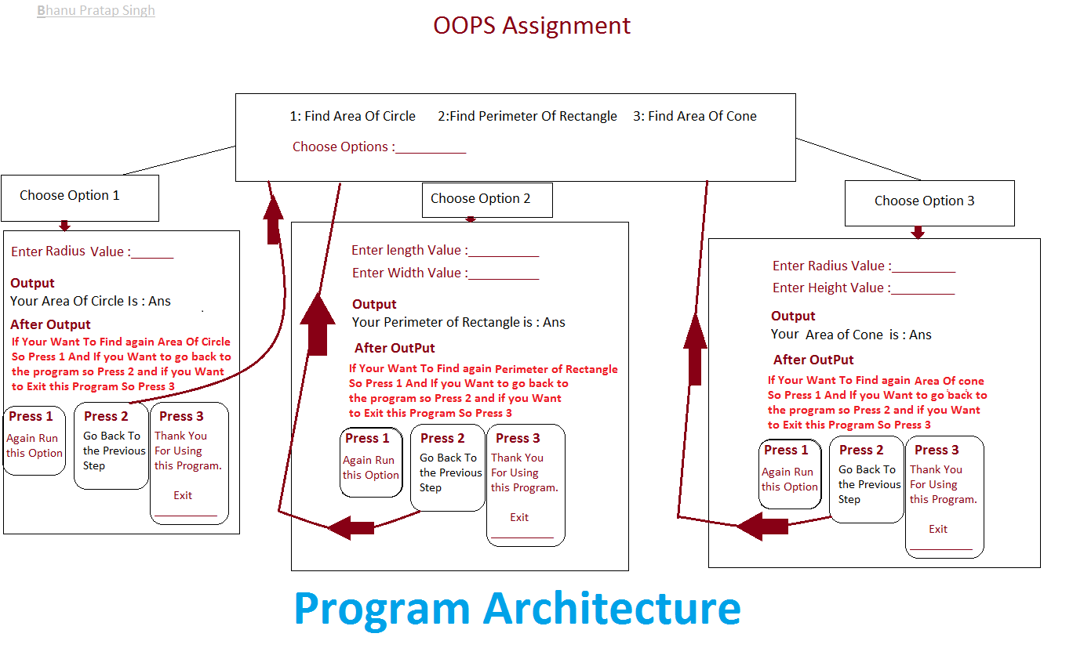

import java.util.Scanner;

import java.io.*;

class as{

static final double pai=Math.PI;

static Scanner inp=new Scanner(System.in);

static void mainp(){

Scanner inp=new Scanner(System.in);

System.out.println("\n[1] Find Area Of Circle [2] Find Perimeter Of Rectangle [3] Find Area of Cone");

System.out.print("Choose Options : ");

int value=inp.nextInt();

if(value==1){

aoc();

}else if(value==2){

por();

}else if(value==3){

cone();

}

}

static void aoc(){

System.out.println("\n==============================");

System.out.print("Enter Radius Value : ");

double value=inp.nextDouble();

double ans=pai*(value*value);

System.out.println("Your Area Of Circle is : "+ans);

System.out.println("\n====================================");

System.out.print("If You Want To Find again Area of Circle So\nPress 1 and If You Want to go back to the\nProgram So Press 2 and If You Want to Exit this Program So Press 3 : ");

int vl=inp.nextInt();

if(vl==1){

aoc();

}else if(vl==2){

System.out.println("======================================");

mainp();

}else if(vl==3){

System.out.println("======================================");

System.out.println("Thank You For Using This Program");

System.out.println("======================================");

}else{

System.out.print("Some thing is Wrong");

}

}

static void por(){

System.out.println("\n==============================");

System.out.print("Enter Length Value : ");

double ln=inp.nextDouble();

System.out.print("Enter Width Value : ");

double wt=inp.nextDouble();

double ans=2*(ln+wt);

System.out.println("Your Perimeter of Rectangle is : "+ans);

System.out.println("\n====================================");

System.out.print("If You Want To Find again Perimeter of Rectangle So\nPress 1 and If You Want to go back to the\nProgram So Press 2 and If You Want to Exit this Program So Press 3 : ");

int vl=inp.nextInt();

if(vl==1){

por();

}else if(vl==2){

System.out.println("======================================");

mainp();

}else if(vl==3){

System.out.println("======================================");

System.out.println("Thank You For Using This Program");

System.out.println("======================================");

}else{

System.out.print("Some thing is Wrong");

}

}

static void cone(){

System.out.println("\n==============================");

System.out.print("Enter Radius Value : ");

double rd=inp.nextDouble();

System.out.print("Enter Height Value : ");

double ht=inp.nextDouble();

double hts = Math.sqrt(rd * rd + ht * ht);

double ans1=(pai*rd*rd)+(pai*rd*hts); //this is a Formula of Area of cone

System.out.println("Your Area of Cone is : "+ans1);

System.out.println("\n====================================");

System.out.println("\n====================================");

System.out.print("If You Want To Find again Area of Cone So\nPress 1 and If You Want to go back to the\nProgram So Press 2 and If You Want to Exit this Program So Press 3 : ");

int vl=inp.nextInt();

if(vl==1){

cone();

}else if(vl==2){

System.out.println("======================================");

mainp();

}else if(vl==3){

System.out.println("======================================");

System.out.println("Thank You For Using This Program");

System.out.println("======================================");

}else{

System.out.print("Some thing is Wrong");

}

}

public static void main(String arg[]){

mainp();

}

}

**Area Of Circle Output**

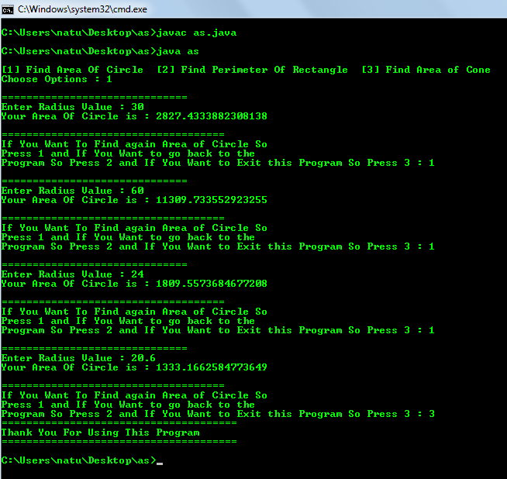

**Perimeter Of Rectangle Output**

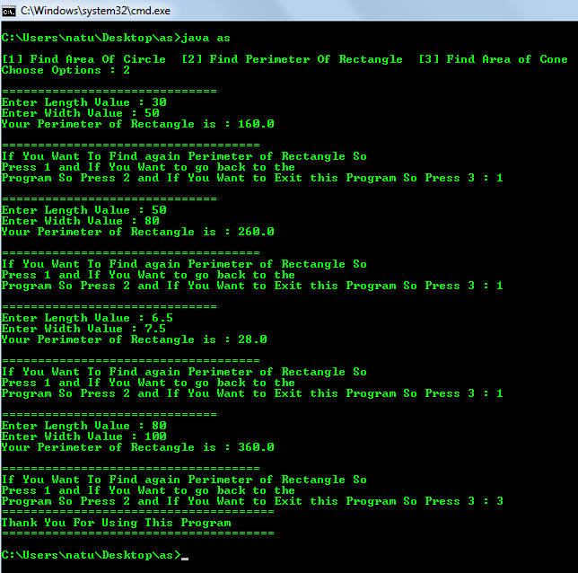

**Area of Cone Output**

